**WIGGINTON PARISH COUNCIL** WARDEN UPDATE: **APRIL/MAY 2024**

|  |  |
| --- | --- |
| **AREA** | **SPORTS FIELD** |
| **TO CHECK** | Gym/Sports equipment, Children’s playground, Car Park, Trees & vegetation, Safety Information, Fencing, Gates, Wooden bollards, Benches, Picnic Tables, Grass height, General ground conditions, Litter and Dog waste bags. |
| **INSPECTION DATES** | 15/4, 22/4, 29/4, 6/5, 13/5 |
| **ISSUES TO REPORT** | 1. Litter picking was undertaken on a weekly basis. 2. Grass height complies with the mowing specification, Soil compaction is evident in the goalmouths impeding drainage (Photo 1). Berkhamsted Raiders are aware. 3. Two football post stanchions have been vandalised (Photo 2). Once football fixtures finish, it might be prudent to remove the goalposts. This will permit ample pitch renovation time for the GM Contractor. Berkhamsted Raiders were notified by the Clerk. 4. A missing screw is missing on a panel on the multi play equipment (Photo 3). Some minor movement was noticeable. 5. The fitness equipment was visually checked and operating correctly. 6. Dog poo bag dispensers were refilled. 7. Outdoor furniture overall is in fair order except for a memorial bench (see outstanding items below). 8. Dense scrub, and overgrown woodland has been cleared from the boundary (Photos 4, 5 & 6), Up to clearance, this area had become a magnet for litter, fly-tipping and discarded dog poo bags. Positive comments received from many visitors/users. 9. A member of the public raised a concern about netting in the car park (Photo 7), believing it is a risk to young children and animals. It is understood the netting is used to prevent footballs striking parked vehicles.   **Outstanding items**   * Charred debris, left behind from the firework display, needs removal. * A new emergency access sign is required on the gate near the village shop. * Memorial bench needs refixing to the ground. * Tree trunk step from the playhouse is decayed and disintegrating (Photo 8). * Wooden support bracket is missing on the large slide. * Plastic cap cover is missing on the Multi Play equipment, designed to protect hands from being grazed on a metal bolt. * Loose eye bolts need tightening on the rope bridge. * New anti-slip tape is required on the multi-play equipment, replacing patches of worn/missing tape. |

|  |  |
| --- | --- |
| **AREA** | **RECREATION GROUND** |
| **TO CHECK** | Fencing, Benches/seats, Trees & vegetation, Grass height, Car Park, Litter & Dog waste bins. |
| **INSPECTION DATES** | 15/4, 22/4, 29/4, 6/5, 13/5 |
| **ISSUES TO REPORT** | 1. Litter picking was carried out on a weekly basis. 2. Furniture was observed in fair condition. 3. Dog poo bag dispensers were refilled. 4. Currently, grass height does not satisfy the requirements of the annual mowing agreement, being high, uneven and in full flower. 2m curving paths, as per agreement, need to be defined within the wilded area. 5. An entry gate was in imminent danger of collapse. This fault was due to a decayed post (Photos 9 & 10). Gate removed. Parish clerk informed, R.M.L Tree and Garden Services had been appointed.   **Outstanding item:**   * Wooden benches need re-fastening to the ground. A bench was recently retrieved from nearby woodland (Photo 11). |

|  |  |
| --- | --- |
| **AREA** | **HIGHWAY’S, PUBLIC FOOTPATHS & DITCHES** |
| **TO CHECK** | Surfaces, Pedestrian routes, Signage inc. finger post, Bench (Oddy Hill), Drainage, Grit bins, Litter, Bollards, Footpaths/Kissing gates, Notice boards, Defibrillator |
| **DATES** | 15/4, 22/4, 29/4, 6/5, 13/5 |
| **ISSUES TO REPORT** | 1. The AED has a 66% charge. Crucial accessories were found in place. An annual inspection has taken place with the engineers and report was received. A sign has been installed by the defibrillator detailing emergency procedures and defibrillator ownership (Photo 12). 2. Litter picking was completed within the village centre, Vicarage Road, Fox Road, Oddy Hill, Wigginton Bottom, Chesham Road (to Crawley’s Lane) and the Twist (upper half). 3. In addition to the above, a highly successful community litter pick took place on the 20th of April. This event involved 22 adults and 4 children participants. A total of thirty-four bags of rubbish and recycling were collected along with some fly tipping items (Photo 13) 4. A pothole in Fox Road was filled by HCC Highways. Ref No: 401004070290. 5. A Safety bollard, shielding a telegraph pole supporting overhead power lines, has been reinstated by HCC Highways (near St Bartholomew Church). Ref No: 401004070728. 6. An overgrown hedge in Wick Road is obstructing access., Pedestrians must enter the road to sidestep the hedge (Photo 14). Parish Clerk alerted. 7. A fly tipped bed mattress was removed from the roundabout at the bottom of Oddy Hill by DBC. Ref No: 887077 (Photo 15). 8. Outbuilding(s) on the former Smith’s Coaches premises can be accessed. Some damage, possibly vandalism, is evident along with structural dilapidation i.e. roof, beams. Left open, this represents a safety risk including arson. WPC may wish to alert the owner (Photos 16 & 17). 9. The Greyhound PH has installed fencing to the front of the car park creating a neat and tidy appearance (Photo 18).   **Outstanding items (HCC).**   * Damaged directional sign – Chesham Road/Vicarage Road junction. HCC ref no: 401003790025. * Blocked drain in Hemp Lane opposite property Kirkdale. Ref No: 401003596160. |

**PHOTOGRAPHS**

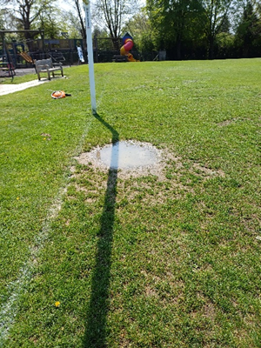 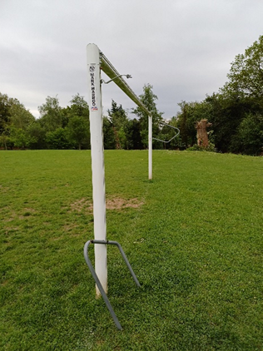 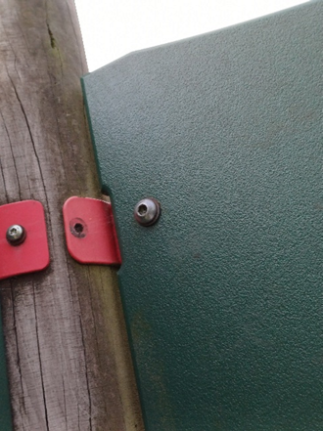

3

2

1

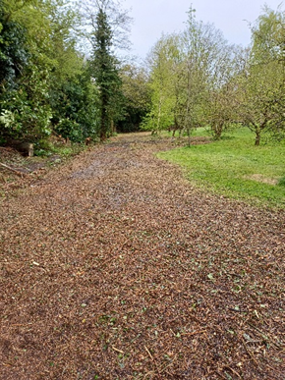 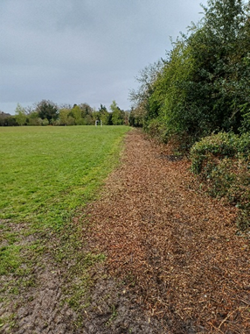 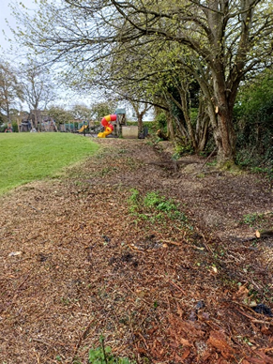

6

5

4

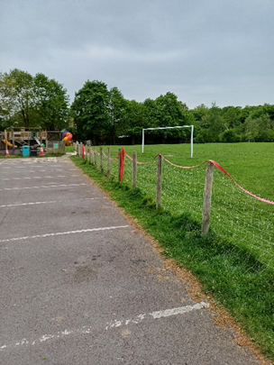 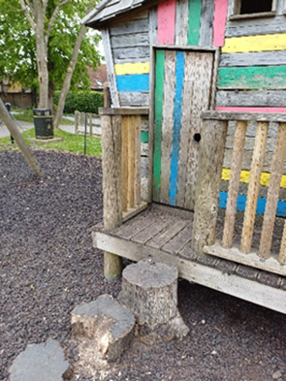 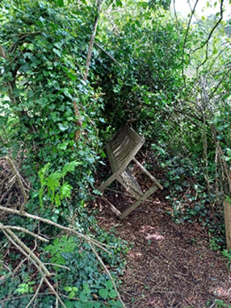

9

8

7

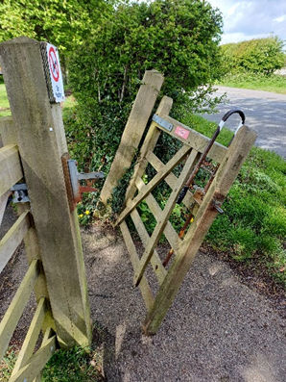 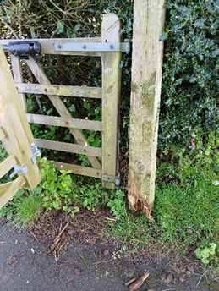 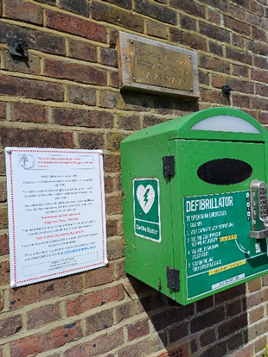

12

11

10

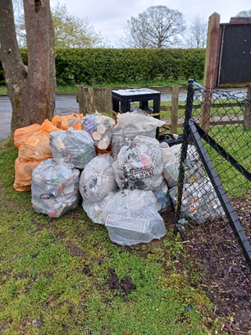 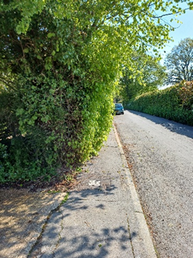 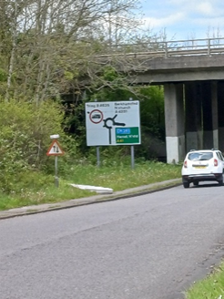

13

15

14

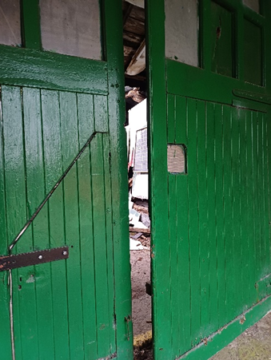 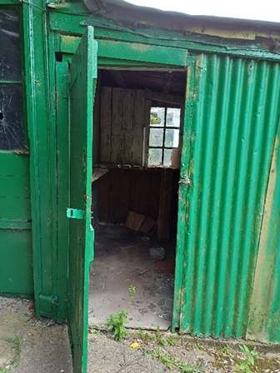

18

17

16